Y4 Arguments for / against

For

(Persuasive letter writing)

Statement:

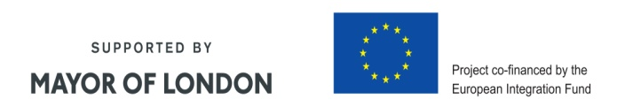

Against